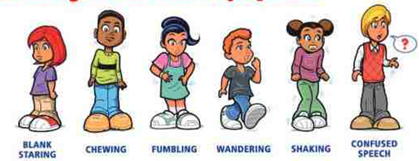

First Aid for Seizure

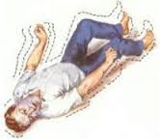

 [](http://www.google.com.eg/imgres?q=look+at+watch&um=1&hl=en&tbo=d&biw=1024&bih=424&tbm=isch&tbnid=iRRltnq8CIKfnM:&imgrefurl=http://www.second-man.com/category/designers/steinwerk-designs&docid=EyvOXIo91XaDPM&imgurl=http://www.second-man.com/wp-content/uploads/Ryan/Steinwerks/look_at_anim.jpg&w=600&h=800&ei=CnYDUYWYI8HbtAb07ICgBg&zoom=1&ved=1t:3588,r:4,s:0,i:88&iact=rc&dur=1651&sig=113805951935470571360&page=1&tbnh=196&tbnw=151&start=0&ndsp=10&tx=107&ty=83) 

[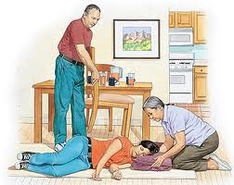](http://www.google.com.eg/imgres?q=instruction+during+seizure&um=1&hl=en&tbo=d&biw=1024&bih=424&tbm=isch&tbnid=K03Nvz0FOprgbM:&imgrefurl=http://www.einstein.edu/einsteinhealthtopic/?articleId=40163&articleTypeId=3&healthTopicid=-1&healthTopicName=HealthSheets&docid=1T92FDpYZRT9ZM&itg=1&imgurl=http://einstein.kramesonline.com/151802.img&w=350&h=278&ei=qN4DUZybEYbvsgaBr4HwBw&zoom=1&ved=1t:3588,r:29,s:0,i:171&iact=rc&dur=4710&sig=107287153877291539308&page=3&tbnh=152&tbnw=186&start=24&ndsp=12&tx=76&ty=85)

